**20PW14**

**Case Study – Pizza Supreme**

A large pizza business makes pizzas and sells them. The pizzas are manufactured and kept in cold storage for not more than two weeks.

The business is split into a number of functional units. There is Production Control, Manufacturing, Stores, Accounts, Sales, Shipping and Purchasing. Production Control are responsible for organising which pizzas to produce in what order and in what quantity. They need to schedule the production of the pizzas according to the current and expected sales orders together with the number of pizzas already in Stores. Manufacturing take the raw materials from the Stores and manufacture pizzas returning the completed goods to the Stores. Accounts deal with the payments for the pizzas when delivered to the customer and the payment to the suppliers of the raw materials. Sales deal with customer orders whilst Purchasing organise the buying of raw material from suppliers. Shipping manage the packing and delivery of the goods to the customer with a delivery note.

When a sales order is received by sales they record what is being ordered and by whom. They also record the details of the expected date of delivery. Production Control access this information and make sure that, if required, pizzas are produced by Manufacturing and are ready in Stores for when the delivery needs to be made.

After the delivery is made Accounts make sure that the customer receives an invoice and that payment for the invoice is received at which time a receipt is issued. Purchasing look at the current stock of raw materials and by using current stock levels, supplier turn around times and quantity to be ordered decide what needs to be ordered on a daily basis. Their aim is never to run out of an ingredient but to minimise the amount of raw material kept in stock.

***System Components:***

**Inputs**: Sales order received by the sales.

**Processing**: Manufacturing.

**Controls:** Production Control.

**Boundary**: Pizzeria.

**Feedback**: Customer review, and staff review on the system.

**Outputs**: Accounts with the invoice.

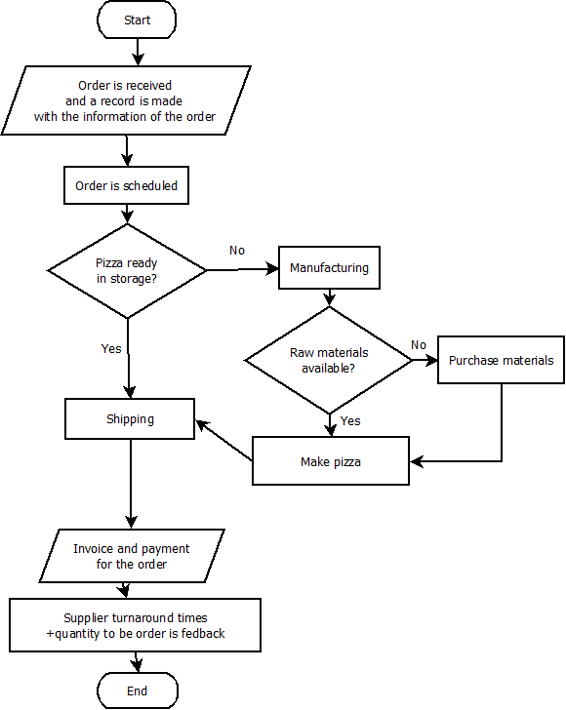

# Case–study Jerome Hospital

Jerome Hospital consists of five doctors a receptionist and a manager. They need an information system to help them to run the facility.

A patient may ring the surgery to make an appointment with a doctor. Each patient nominally has a doctor associated with him or her but they may often opt to see any doctor in the surgery that is available. The receptionist sees which doctors are on duty on which days and offers appointment alternatives from which the patient may choose. If an appointment is not available within a short time and the patient must be seen quickly they are asked to attend an emergency surgery that takes place every evening between 5 and 6 p.m. The appointment can be 5, 10 or 20 minutes long, dependent on the reported reason for seeing the doctor. This reason is recorded on the system. Sometimes patients ring to cancel appointments. Appointments may be made for up to six weeks in advance. Appointments that are more than 3 weeks old are automatically deleted from the system. Some appointments are for a doctor to go and visit a patient at home when the patient cannot come to the surgery. Every day one of the doctors is available for home visits in the afternoon.

A record is kept of each patient and the treatments they have received for any ailments they may have had. Here are recorded many details such as allergies, details of which drugs patients have been administered in which quantities and when. Also relevant personal details of each patient are recorded. Typically the doctor who sees a patient will want access to this information before deciding on the relevant treatment to give. When the doctor prescribes treatment, details will be recorded in the patient’s record.

Repeat prescriptions are automatically produced by the system and are available for collection at the surgery by the patient. At any time a doctor may suspend or cancel the prescriptions.

Patients may register with the surgery providing the number registered to each doctor is not above a certain maximum. Sometimes patients die or leave the area. In this case the patient is removed from the system and their details are archived. The manager is responsible for dealing with this aspect.

***System Components:***

**Inputs:** Patients calling in for appointments.

**Processing**: Reception.

**Controls**: Manager.

**Boundary**: Jerome Hospital.

**Feedback**: Patients review, and doctors’ review on the system.

**Outputs**: Prescriptions made by the doctors.